REAL-TIME SIGN LANGUAGE RECOGNITION
A PROJECT REPORT

Submitted by

Vinayak K Asish (22MIM10060)
Harisankar G (22MIM10063)
Cherin Yacoob Wattacheril (22MIM10074)
Neha R (22MIM10089)

in partial fulfillment for the award of the degree
of

INTEGRATED MASTER OF TECHNOLOGY

in

ARTIFICIAL INTELLIGENCE



SCHOOL OF COMPUTING SCIENCE AND ENGINEERING
AND ARTIFICIAL INTELLIGENCE

VIT BHOPAL UNIVERSITY
KOTHRIKALAN, SEHORE
MADHYA PRADESH - 466114

MAY 2024

VIT BHOPAL UNIVERSITY, KOTHRIKALAN, SEHORE
MADHYA PRADESH – 466114

BONAFIDE CERTIFICATE

Certified that this project report titled “REAL-TIME SIGN LANGUAGE RECOGNITION” is the bonafide work of “VINAYAK K ASISH (22MIM10060), HARISANKAR G (22MIM10060), CHERIN YACOOB WATTACHERIL (22MIM10074), NEHA R(22MIM10089)” who carried out the project work under my supervision. Certified further that to the best of my knowledge the work reported at this time does not form part of any other project/research work based on which a degree or award was conferred on an earlier occasion on this or any other candidate.

PROGRAM CHAIR
Dr. Devaraju S
School of Computing Science Engineering and Artificial Intelligence.
VIT BHOPAL UNIVERSITY
PROJECT GUIDE
Dr. Nancy Kumari
School of Computing Science Engineering and Artificial Intelligence
VIT BHOPAL UNIVERSITY

The Project Exhibition I Examination is held on _______________
SCHOOL OF COMPUTING SCIENCE ENGINEERING AND ARTIFICIAL INTELLIGENCE
CERTIFICATE

This is to certify that the thesis titles REAL-TIME SIGN LANGUAGE RECOGNITION submitted by VINAYAK K ASISH (22MIM10060), HARISANKAR G (22MIM10060), CHERIN YACOOB WATTACHERIL (22MIM10074), NEHA R(22MIM10089) to VIT Bhopal University, in partial fulfillment of the requirement for the award of the degree of Integrated Master of Technology in Artificial Intelligence is a bona-fide work carried out under my supervision. The thesis fulfills the requirement as per the regulation of this University and in my opinion meets the necessary standards for submission. The contents of this thesis have not been submitted and will not be submitted either in part or in full, for the award of any other degree or diploma and the same is certified.

Supervisor

Signature
Name: Dr. Nancy Kumari
Designation:
Date:

Reviewer 1

Signature
Name: Dr.Rudra Kalyan Nayak
Designation:
Date:

A viva-voce was conducted on:…………
Program Chair

Signature
Name: Dr. S. Devaraju
Designation:
Date:

Reviewer 2

Signature
Name:
Designation:
Date:

ACKNOWLEDGEMENT

I am ineffably indebted to Dr. G. Viswanathan (Chancellor), Vellore Institute of Technology, Bhopal, and Dr. U. Kamachi Mudali (Vice-Chancellor), Vellore Institute of Technology, Bhopal.
I would like to express my profound thanks to Dr. Pon Harshavardhanan (Dean of SCAI) for their support and encouragement towards me at every stage in the successful completion of my project and my degree.
I would like to extend my thanks and unbound sense for the timely help and assistance given to Dr. Devaraju S (Program Chair of Integrated MTech in Artificial Intelligence) in completing the project.
The satisfaction and euphoria that accompanies the successful completion of any task would be incomplete without the mention of the people who made it possible. If there is a driving force that kept me going on in doing the project, it is the constant support of my internal guide Dr. Nancy Kumari. I present my sincere and heartiest thanks to him, for giving me a patience hearing and clearing my doubts.
I take this opportunity to thank my parents and friends for their constant support and encouragement throughout this training.

Vinayak K Asish
(22MIM10060)
Harisankar G
(22MIM10063)
Cherin Yacoob Wattacheril
(22MIM10074)
Neha R
(22MIM10089)
LIST OF ABBREVIATIONS

SLR: Sign Language Recognition
LSTM: Long Short-Term Memory
NLP: Natural Language Processing
CNN: Convolutional Neural Network
FPS: Frames Per Second
APP: Appendices
GPU: Graphics Processing Unit
CPU: Central Processing Unit
MP: Mediapipe
ASL: American Sign Language
ISL: Indian Sign Language
LIST OF FIGURES AND GRAPHS
FIGURE NO. | TITLE | PAGE NO.
1 | Code for Data Collection | 17
2 | LSTM Layers | 17
3 | Code for the Output | 18
4.1 | Categorical Accuracy on the train data | 20
4.2 | Loss of Data while training (EPOCH loss) | 20
4.3 | Working of the model | 21

ABSTRACT
This project introduces a novel approach to sign language detection by employing Long Short-Term Memory (LSTM) neural networks to analyze sequential frame data rather than the conventional frame-by-frame analysis [1]. Utilizing the advanced capabilities of LSTM, which is adept at processing time-series data [2], our model interprets complex gestures captured across multiple frames, providing a dynamic and fluid understanding of sign language. The data collection for this project used the MediaPipe framework to capture human body movements [3]. These key points were stored in numpy arrays for efficient processing [4]. In practical applications, the system captures real-time video streams, processes the last 30 frames through the trained LSTM model, and promptly outputs the gesture recognition results. This setup not only demonstrates the model’s capability in a controlled environment but also provides a foundation for real-time interaction and feedback systems. The project has potential for expansion with the integration of NLP tools for gesture-to-speech translation and the development of web-based sign language education platforms, enhancing communication aids and paving the way for innovative learning tools in sign language [5].

TABLE OF CONTENTS
CHAPTER NO. | TITLE | PAGE NO.
1 | CHAPTER-1:  PROJECT DESCRIPTION AND OUTLINE  Introduction  1.2 Motivation for the work  1.5 Problem Statement  1.6 Objective of the work | 12  .  .  13
2 | CHAPTER-2:  RELATED WORK INVESTIGATION  2.1 Literature Review | 14  15
3 | CHAPTER-3:  PROPOSED METHODOLOGY  3.1 Problem Definition  3.2 Framework Overview  3.3 Architecture  3.4 Algorithm | 16  .  .  17  .  18
4 | CHAPTER-4:  RESULTS AND DISCUSSION  4.1 High Accuracy and Overfitting Concerns  4.2 Impact of Training Dataset Size  4.3 Utilization of Performance Evaluation Metrics  4.4 Implication and Future Directions  4.5 Working of the model | 19  .  .  .  20  .  .  21
5 | CHAPTER-5:  FUTURE SCOPE  6.1 Dataset Expansion and Balance  6.2 Model architecture Innovations  6.3 Contextual Awareness and Adaptability  6.4 Enhanced User Experience and Accessibility | 22  .  .  .  .  23
6 | CHAPTER-6:  CONCLUSION | 24
7 | References | 25

INTRODUCTION

The Real-Time Sign Language Recognition System represents a pivotal advancement in assistive technologies, utilizing state-of-the-art neural network models to decode sign language instantly This innovation enables seamless communication between the deaf and the hard of hearing individuals and those unfamiliar with sign language, fostering inclusiveness and eliminating communication barriers [5, pp. 1698-1713; 6; 10; 11].

1.1 Motivation for the Work

The motivation behind this work stems from the longstanding communication barrier between sign language users and non-users, which has posed significant challenges in various domains such as education, workplaces, and routine interactions. Traditional methods of bridging this gap, such as interpreters or written communication, often suffer from delays or inaccuracies, hindering efficient communication [2]. Furthermore, the lack of accessibility to sign language interpretation services in certain contexts exacerbates these challenges [3]. This project seeks to address these issues by leveraging technological solutions that can interpret sign language in real-time, offering a promising avenue for clearer and faster communication and understanding. By harnessing the power of artificial intelligence and machine learning, we aim to develop systems capable of accurately recognizing and translating sign language gestures into spoken or written language, thereby enhancing inclusivity and accessibility for sign language users. Through this endeavor, we aspire to empower individuals within the deaf and hard-of-hearing community by providing them with tools to communicate effectively and participate fully in various aspects of society [6].

1.2 Introduction to the Project including Techniques

Neural Networks and MP:
The core of our system is built on the LSTM neural network that excels in processing sequential and time-series data. For data collection, we utilized the MediaPipe framework, which allows for real-time, high-fidelity tracking of human body key points. This combination of LSTM and MediaPipe provides a robust framework capable of capturing and interpreting the dynamic and complex gestures involved in sign language.

1.3 Problem Statement

Despite the widespread use of sign language around the world, there remains a significant lack of technological tools that can translate sign language into spoken language or text in real time. This system aims to fill this void by providing a reliable and efficient tool for real-time sign language translation and recognition.

1.4 Objective of the Work

The primary objective of this project is to develop and implement a real-time sign language recognition system that:
- Enhances communication between deaf or hard-of-hearing individuals and the general public.
- Provides a learning platform for individuals interested in learning sign language.
- Integrates seamlessly into various public and educational infrastructures as an assistive tool.
- Easy to add new sign languages and many kinds of sign languages like ASL,ISL etc

RELATED WORK INVESTIGATION

Advancements in Sign Language Recognition Sign language recognition (SLR) plays a crucial role in facilitating communication for the speech and hearing-impaired community. Over the past two decades, significant strides have been made in developing various methods and technologies to improve SLR accuracy and efficiency. This literature review aims to provide an overview of the diverse approaches and findings in the field.

Traditional Neural Network Approaches: Early research, such as the work by Vivek A. Sujan and Marco Antonio Meggiolaro (2000) [1], focused on implementing competitive learning in neural networks, resulting in improved recognition accuracy of up to 89%. These approaches laid the foundation for subsequent developments in SLR technology.

Sensor-Based Systems: Several studies, including those by Hou-Hsien Lee, Chang-Jung Lee, and Chih-Ping Lo (2011), and Nandina Anudeep (2022) [3][11], explored the use of depth-sensing cameras and simultaneous video sensors to capture sign language gestures accurately. By gathering data about distances between points on the signer's body and the camera, these systems build 3D models for gesture recognition, enabling more precise tracking of hand and body actions.

Machine Learning Algorithms: Research by Huang Jialiang et al. (2017) [5] introduced an improved bisecting K-means chameleon clustering algorithm coupled with a back-propagation neural network to enhance stability and fault tolerance in SLR systems. This approach demonstrated advancements in clustering techniques for feature extraction and classification tasks.

Feature Extraction and Filtering: Proposed methods, such as the one by Li Houqiang, Junfu Pu, and Zhou Wengang (2019) [7], incorporated feature extraction units to identify key elements in sign language gestures. Additionally, Wang Qingshan et al. (2020) introduced a novel approach involving the use of sensor bracelets to collect gesture signals and filtering noise during the feature extraction stage, thereby improving recognition accuracy.

Deep Learning Models: Recent advancements in deep learning have led to the development of sophisticated models for SLR. The DenseTCN model, as proposed by Dan Guo et al. (2021), utilizes convolutional neural network (CNN) operations to encode temporal cues of continuous gestures, enabling robust recognition of dynamic sign language sequences. Similarly, A Sunitha Nandhini et al. (2021) implemented a convolutional neural network-based approach for SLR, leveraging the power of deep learning to achieve accurate recognition results.

Challenges and Future Directions: Despite these advancements, SLR remains a challenging task, especially in real-world settings. Issues such as variability in signing styles, occlusions, and background clutter continue to pose significant challenges for existing systems. Future research efforts may focus on developing more robust and adaptive SLR algorithms capable of addressing these challenges while also exploring multimodal approaches that combine visual, spatial, and temporal information for enhanced recognition performance.

In conclusion, the literature reviewed here demonstrates the evolution of SLR technology from traditional neural network approaches to modern deep learning models. While significant progress has been made, ongoing research efforts are essential to overcome remaining challenges and advance the state-of-the-art in sign language recognition, ultimately improving communication accessibility for the speech and hearing-impaired community.
PROPOSED METHODOLOGY

3.1 Problem Definition

The Real-Time Sign Language Recognition System aims to address the communication barriers between sign language users and non-users by providing an efficient and accurate real-time translation system. The challenge lies in capturing and interpreting the dynamic and expressive nature of sign language gestures with a high level of accuracy and speed.

3.2 Framework Overview

1. Data Collection:
Utilize the MediaPipe framework to capture human body key points from a dataset of 30 videos, each 5 seconds long, resulting in 30 frames per second. The keypoints per frame will be stored in a multiple numpy arrays as x,y,z coordinates.
-Organize and preprocess the captured data into sequences for training and validation.

2. LSTM Model Variation:
- Implement six variations of Long Short-Term Memory (LSTM) models to process the sequential data from the videos and categorize sign language gestures effectively. The first three are LSTM layers and next three are Dense Layers in which last layer decides the no of categories.

3. Real-Time Demonstration Module
- Integrate the trained LSTM models into a real-time system capable of processing live video input, providing instant sign language recognition through categorization. It will collect 5 sec sequences live from the device and verify the sequence with model to display the prediction.

3.3 Architecture

1. Data Collection Module:
- Captures and preprocesses human body key points using the MediaPipe framework, building a comprehensive dataset suitable for training the LSTM models.
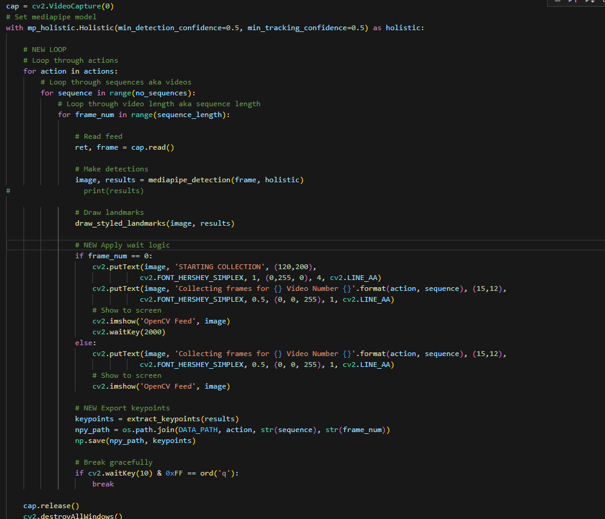
Figure 1

2. LSTM Model Training:
- Utilizes the carefully organized sequential data from the dataset to train the six LSTM model variations, each specializing in categorization based on the complex and dynamic nature of sign language gestures.
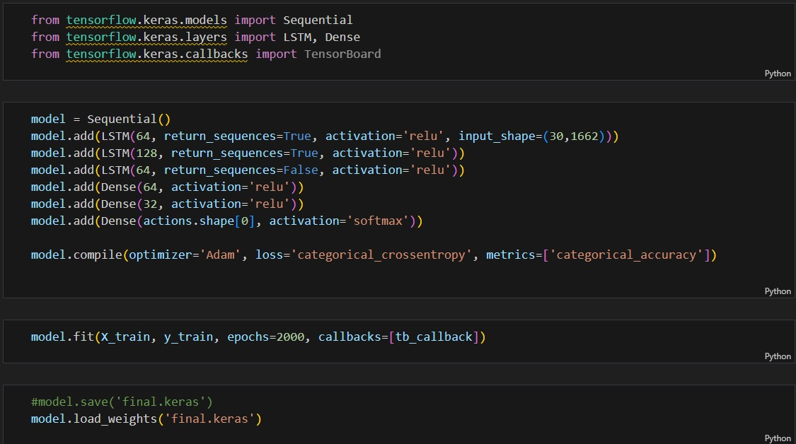
Figure 2

3. Real-Time Demonstration Module:
- Integrates the trained LSTM models into a real-time system, where live video input is processed, and the recognized sign language gestures are instantly outputted.
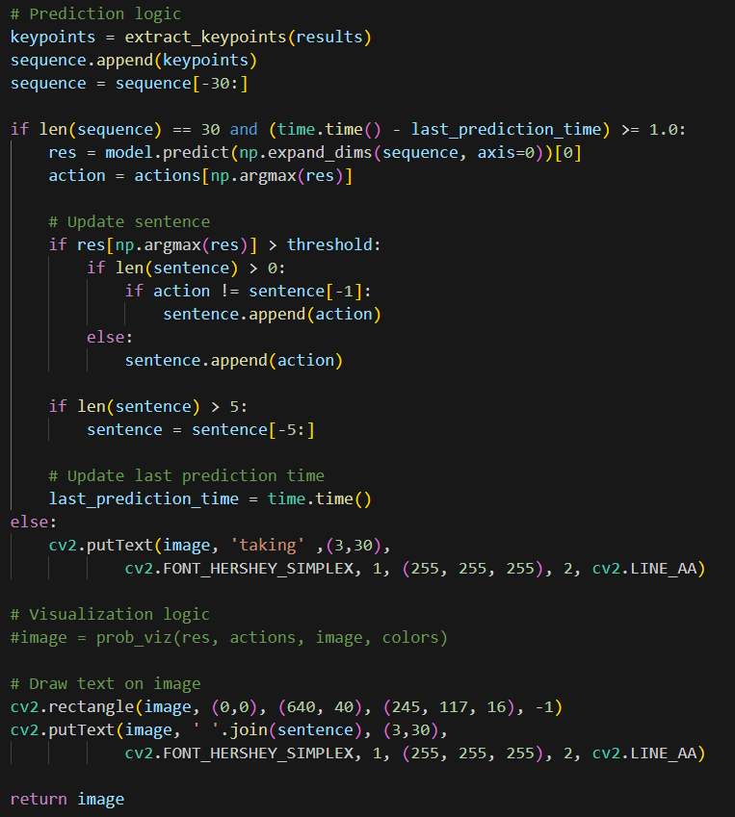
Figure 3

3.4 Algorithm

1.Data Collection and Preprocessing:
- Extract human body key points from 30 videos, each 5 seconds long, resulting in a dataset of 30 frames per second per video

2. LSTM Model Training and Categorization:
- Train the six variations of the LSTM models using the sequential data, focusing on capturing and learning the temporal dependencies and dynamic gestures present in sign language.

3. Real-Time Demonstration and Categorization:
- Develop a real-time system that integrates the trained LSTM models to process live video input, instantly categorizing and recognizing sign language gestures.

This comprehensive methodology underscores the systematic approach to building a robust, real-time sign language recognition system, encompassing data acquisition, model training, and real-time demonstration for seamless communication and inclusion.

RESULTS AND DISCUSSIONS

The results of the model training and testing process revealed several noteworthy aspects that warrant in-depth discussion, particularly in relation to the model's accuracy, overfitting concerns, and performance evaluation metrics. By dissecting the intricacies of the results and their implications, we can glean valuable insights into the efficacy of the model and identify potential avenues for refinement and improvement.

4.1 High Accuracy and Overfitting Concerns

The consistent observation of a near-perfect accuracy of 1.0 during testing raised legitimate concerns regarding potential overfitting of the model. Overfitting, as evidenced in this scenario, occurs when a model becomes overly tailored to the intricacies of the training dataset, impeding its ability to generalize effectively to new, unseen data. This phenomenon manifests as high accuracy during training or testing, only to exhibit reduced accuracy in real-world prediction scenarios. The discrepancy between the near-perfect testing accuracy and the model's performance in actual predictions, which yielded about 96% accuracy, strongly suggests that the model may have memorized specific examples from the training data rather than learning generalizable patterns.

4.2 Impact of Training Dataset Size

The possibility that the small size of the training dataset contributed to the observed overfitting adds an additional layer of complexity to the results. A limited dataset often fails to provide the requisite variability for the model to capture broader trends and patterns. Since we require custom sequential data for this project we had limited resources. Consequently, the model excels in classifying the training data but struggles to generalize effectively to new, unseen data, leading to concerns about its real-world applicability.

4.3 Utilization of Performance Evaluation Metrics

The utilization of a comprehensive suite of performance evaluation metrics, including the confusion matrix and its subsequent use in calculating the model's accuracy and we got up to 83.34% on the training data and by using tensor board we were able to visualize the training curve that defined categorical accuracy as well as the data loss per epoch and we were able to solve at a reasonable categorical accuracy at >90% and epoch data loss at <.4 .

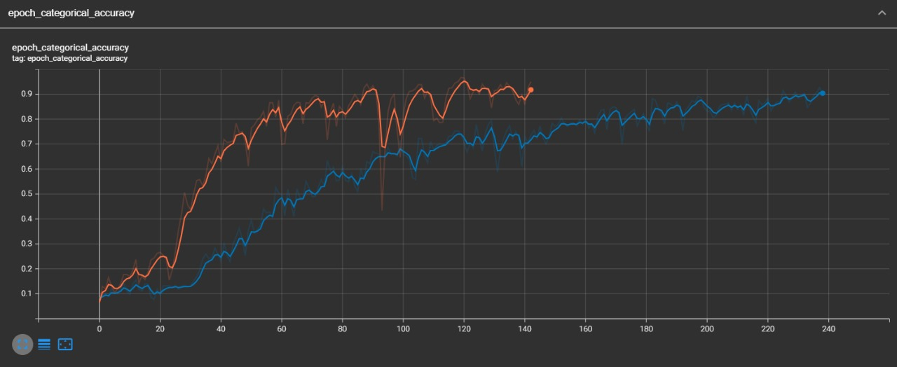
Categorical Accuracy (4.1)
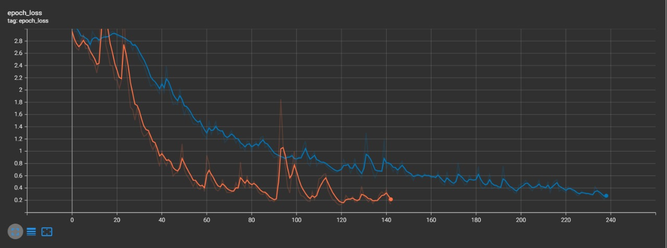
Data Loss per Epoch(4.2)

4.4 Implications and Future Directions

The confluence of high accuracy, overfitting concerns, and the impact of the training dataset size underscores the nuanced nature of building and refining a real-time sign language recognition model. Moving forward, addressing the overfitting concerns through strategies such as data augmentation, regularization techniques, and potentially expanding the training dataset size should be a critical focus. Additionally, fine-tuning the model to optimize its generalization capability while retaining its high accuracy in testing is paramount for its real-world utility.

4.5 Working of the Model
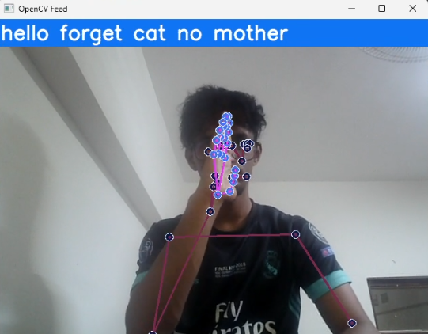
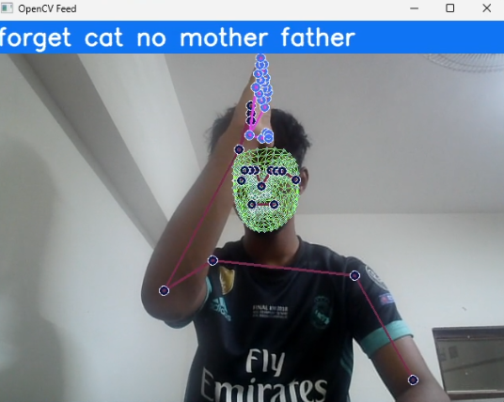
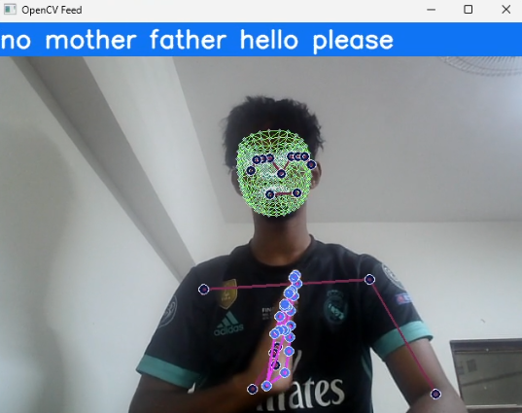

4.3

FUTURE SCOPE

The future prospect of the real-time sign language recognition system encompasses a broad spectrum of advancements and optimizations, each geared toward elevating the system's functionality, inclusivity, and overall impact. Unveiling an array of strategic enhancements and pioneering methodologies, the future scope of the project is poised to reshape the landscape of sign language recognition technology, redefining inclusivity and accessibility.

5.1 Dataset Expansion and Balance:

1. Automated Dataset Augmentation:
- Implement automated scripting to swap left and right hand gestures, effectively doubling the dataset size while ensuring a more balanced representation of both orientations.

2. Bias Mitigation and Generalization:
- Diversify the dataset to mitigate biases and improve the robustness and generalization capabilities of the model, laying the groundwork for a more inclusive and reliable real-time sign language recognition system.

5.2 Model Architecture Innovations:

1. Incorporating Face-to-Hand Ratio:
- Introduce the novel concept of leveraging the ratio of face to hand as a key input parameter in the model architecture, enhancing the discernment and interpretation of sign language gestures by embracing the spatial and contextual relationship between facial expressions and hand movements.

2. Hybrid Model Designs:
- Explore the fusion of LSTM with other advanced architectures such as Transformer models to harness the synergies between different neural network paradigms, potentially unlocking new dimensions of proficiency and accuracy in sign language recognition.

5.3 Contextual Awareness and Adaptability:

1. Contextual Sign Language Understanding:
- Advance the model's contextual awareness by integrating natural language processing (NLP) capabilities to comprehend the semantic nuances of sign language, empowering the system to interpret gestures within their broader linguistic and communicative context.

2. User-Specific Customization:
- Pave the way for personalized user models by incorporating adaptive learning mechanisms that tailor the recognition system to individuals' unique signing styles, dialects, and idiosyncrasies, ensuring a more personalized and attuned communication experience.

5.4 Enhanced User Experience and Accessibility:

1. Real-Time Feedback Mechanisms:
- Introduce real-time feedback mechanisms such as gesture corrections and interactive training sessions, cultivating a dynamic and responsive learning environment for users to refine their signing proficiency.

2. Integrated Accessibility Features:
- Seamlessly integrate the sign language recognition system with a diverse array of platforms, devices, and applications, fostering widespread accessibility and usability for individuals across varied contexts and settings.

The future trajectory of the real-time sign language recognition system intertwines pioneering technological frontiers, conscientious inclusivity, and unwavering commitment to redefining the contours of digital communication. These strategic advancements and innovative horizons collectively converge to herald a new era of universal accessibility, empathy-driven technology, and enriched human connectivity.
CONCLUSION

The Real-Time Sign Language Recognition System represents a significant stride forward in assistive technology, aimed at bridging longstanding communication gaps between sign language users and non-users. Through the integration of advanced neural network models, particularly LSTM networks and the MP framework, this system enables instantaneous decoding and translation of sign language gestures into spoken or written language. The motivation behind this work stems from the urgent need to enhance communication accessibility for the deaf and hard of hearing community, addressing challenges in education, workplaces, and everyday interactions where traditional methods fall short. By leveraging the power of artificial intelligence and machine learning, this innovative solution promotes inclusivity and empowerment, empowering individuals to participate fully in society.

The systematic approach outlined in this project—from data collection and LSTM model training to real-time demonstration—demonstrates a robust methodology for building a reliable and efficient sign language recognition system. However, challenges such as overfitting and dataset limitations underscore the ongoing need for refinement and optimization. By expanding datasets, diversifying model architectures, and integrating contextual awareness, the next phase aims to enhance accuracy, adaptability, and user experience. These strategic advancements will not only refine the current system but also pave the way for broader accessibility and inclusivity across diverse contexts and user profiles. In essence, the Real-Time Sign Language Recognition System heralds a new era of assistive technology, where cutting-edge AI capabilities converge with a commitment to inclusivity, empathy, and universal accessibility. Through continuous innovation and refinement, this technology holds the potential to transform communication dynamics, fostering a more connected and inclusive world for all [11].

REFERENCES

1. Sujan, Vivek A., and Marco A. Meggiolaro. "Sign language recognition using competitive learning in the HAVNET neural network." Applications of Artificial Neural Networks in Image Processing V. Vol. 3962. SPIE, 2000.
2. Cooper, Helen, Brian Holt, and Richard Bowden. "Sign language recognition." Visual Analysis of Humans: Looking at People. London: Springer London, 2011. 539-562.
3. Lee, Hou-Hsien, Chang-Jung Lee, and Chih-Ping Lo. "Sign language recognition system and method." U.S. Patent Application 12/852,512, filed November 10, 2011.5.Karayılan, Tülay, and Özkan Kılıç. "Sign language recognition." 2017 International conference on computer science and engineering (UBMK). IEEE, 2017.
4. Pathan, Refat Khan, et al. "Sign language recognition using the fusion of image and hand landmarks through multi-headed convolutional neural network." Scientific Reports 13.1 (2023)
5. S Bragg, Danielle, et al. "Sign language recognition, generation, and translation: An interdisciplinary perspective." Proceedings of the 21st International ACM SIGACCESS Conference on Computers and Accessibility. 2019.
6.Bouamor, Houda, Juan Pino, and Kalika Bali. "Proceedings of the 2023 Conference on Empirical Methods in Natural Language Processing." Proceedings of the 2023 Conference on Empirical Methods in Natural Language Processing. 2023.
7. Zhou, Hao, et al. "Improving sign language translation with monolingual data by sign back-translation." Proceedings of the IEEE/CVF Conference on Computer Vision and Pattern Recognition. 2021.
8. Wan Wang, Qingshan, et al. "Generalizations of wearable device placements and sentences in sign language recognition with Transformer-based model." IEEE Transactions on Mobile Computing (2024).
9. Guo, Dan, et al. "Sign Language Recognition." Multimedia for Accessible Human Computer Interfaces (2021): 23-59.
10. Srivastava, Sharvani, et al. "Sign language recognition system using TensorFlow object detection API." International conference on advanced network technologies and intelligent computing. Cham: Springer International Publishing, 2021.
11. Sunitha Nandhini, A., et al. "Sign language recognition using convolutional neural network." Journal of Physics Conference Series. Vol. 1916. No. 1. 2021

